1. First Create Main.tf and provider.tf
2. After that configure the access key and secret.
3. If we don’t know the subnets than write write dynamic so that once it will create than it will call.

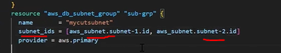

1. **B**elow means create first subnet than RDS.

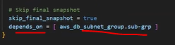

1. When we will create RDS Subnet should be in different AZ. Otherwise it will through error.

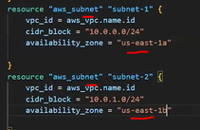

1. Password should be update in secret manager. It should not be hard coded. Here we will use datasourse concept.
2. For RDS configuration we will go terraform0730 repo and look all the code details.